For All: The Power of Allyship and Belonging – Social Media Toolkit
Instructions: Curated social media copy has been created exclusively for the LGBT Great community to use on their social media platforms. You can simply copy and paste the designated text into the corresponding graphic asset, as shown in the table below. These descriptions can be modified to your liking; we have provided three options to help you shape your social media announcement.
Tags: Please tag LGBT Great into the posts. Our tags are shown at the end of this document.
Asset | Copy
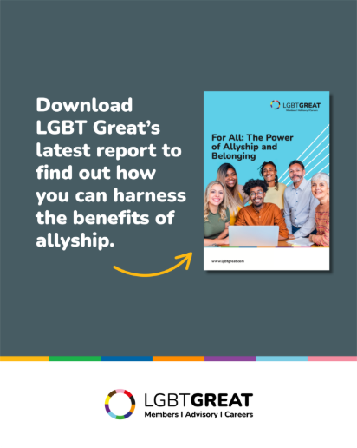 | As proud supporter of LGBT Great, I wanted to share their new research ‘For All: The Power of Allyship and Belonging’ – a groundbreaking global study redefining what it means to be an ally at work.  The findings are clear: 9 in 10 professionals report improvements at work because of cultures of allyship and belonging.  Download the report here: https://www.lgbtgreat.com/For-All-Full-Report  Find out more: www.lgbtgreat.com/For-all  #TheBelongingAdvantage #LGBTGreat #ForAll #Allyship #SeeingIsBelieving
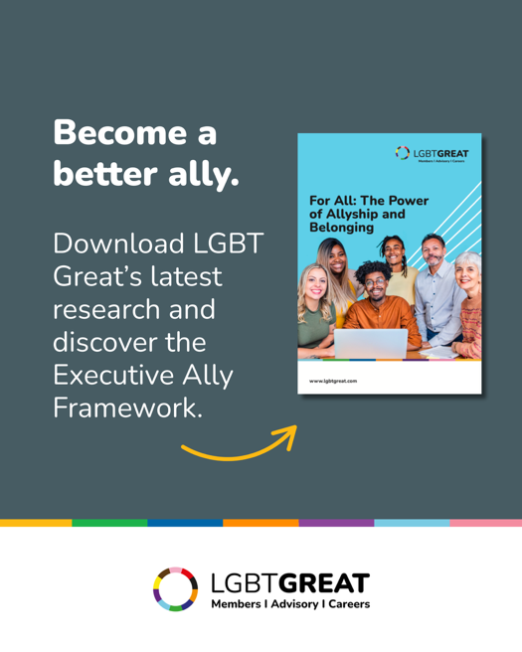 | The new For All: The Power of Allyship and Belonging report from @LGBT Great shows that visible allyship from senior leaders is crucial to building cultures of inclusion and belonging.  Through sharing this research, I hope to empower more leaders to take action to accelerate inclusion, enhance workplace allyship and inspire others to do the same.  Discover the Executive Ally Framework by downloading the full report here: https://www.lgbtgreat.com/For-All-Full-Report  #TheBelongingAdvantage #LGBTGreat #ForAll #Allyship #SeeingIsBelieving
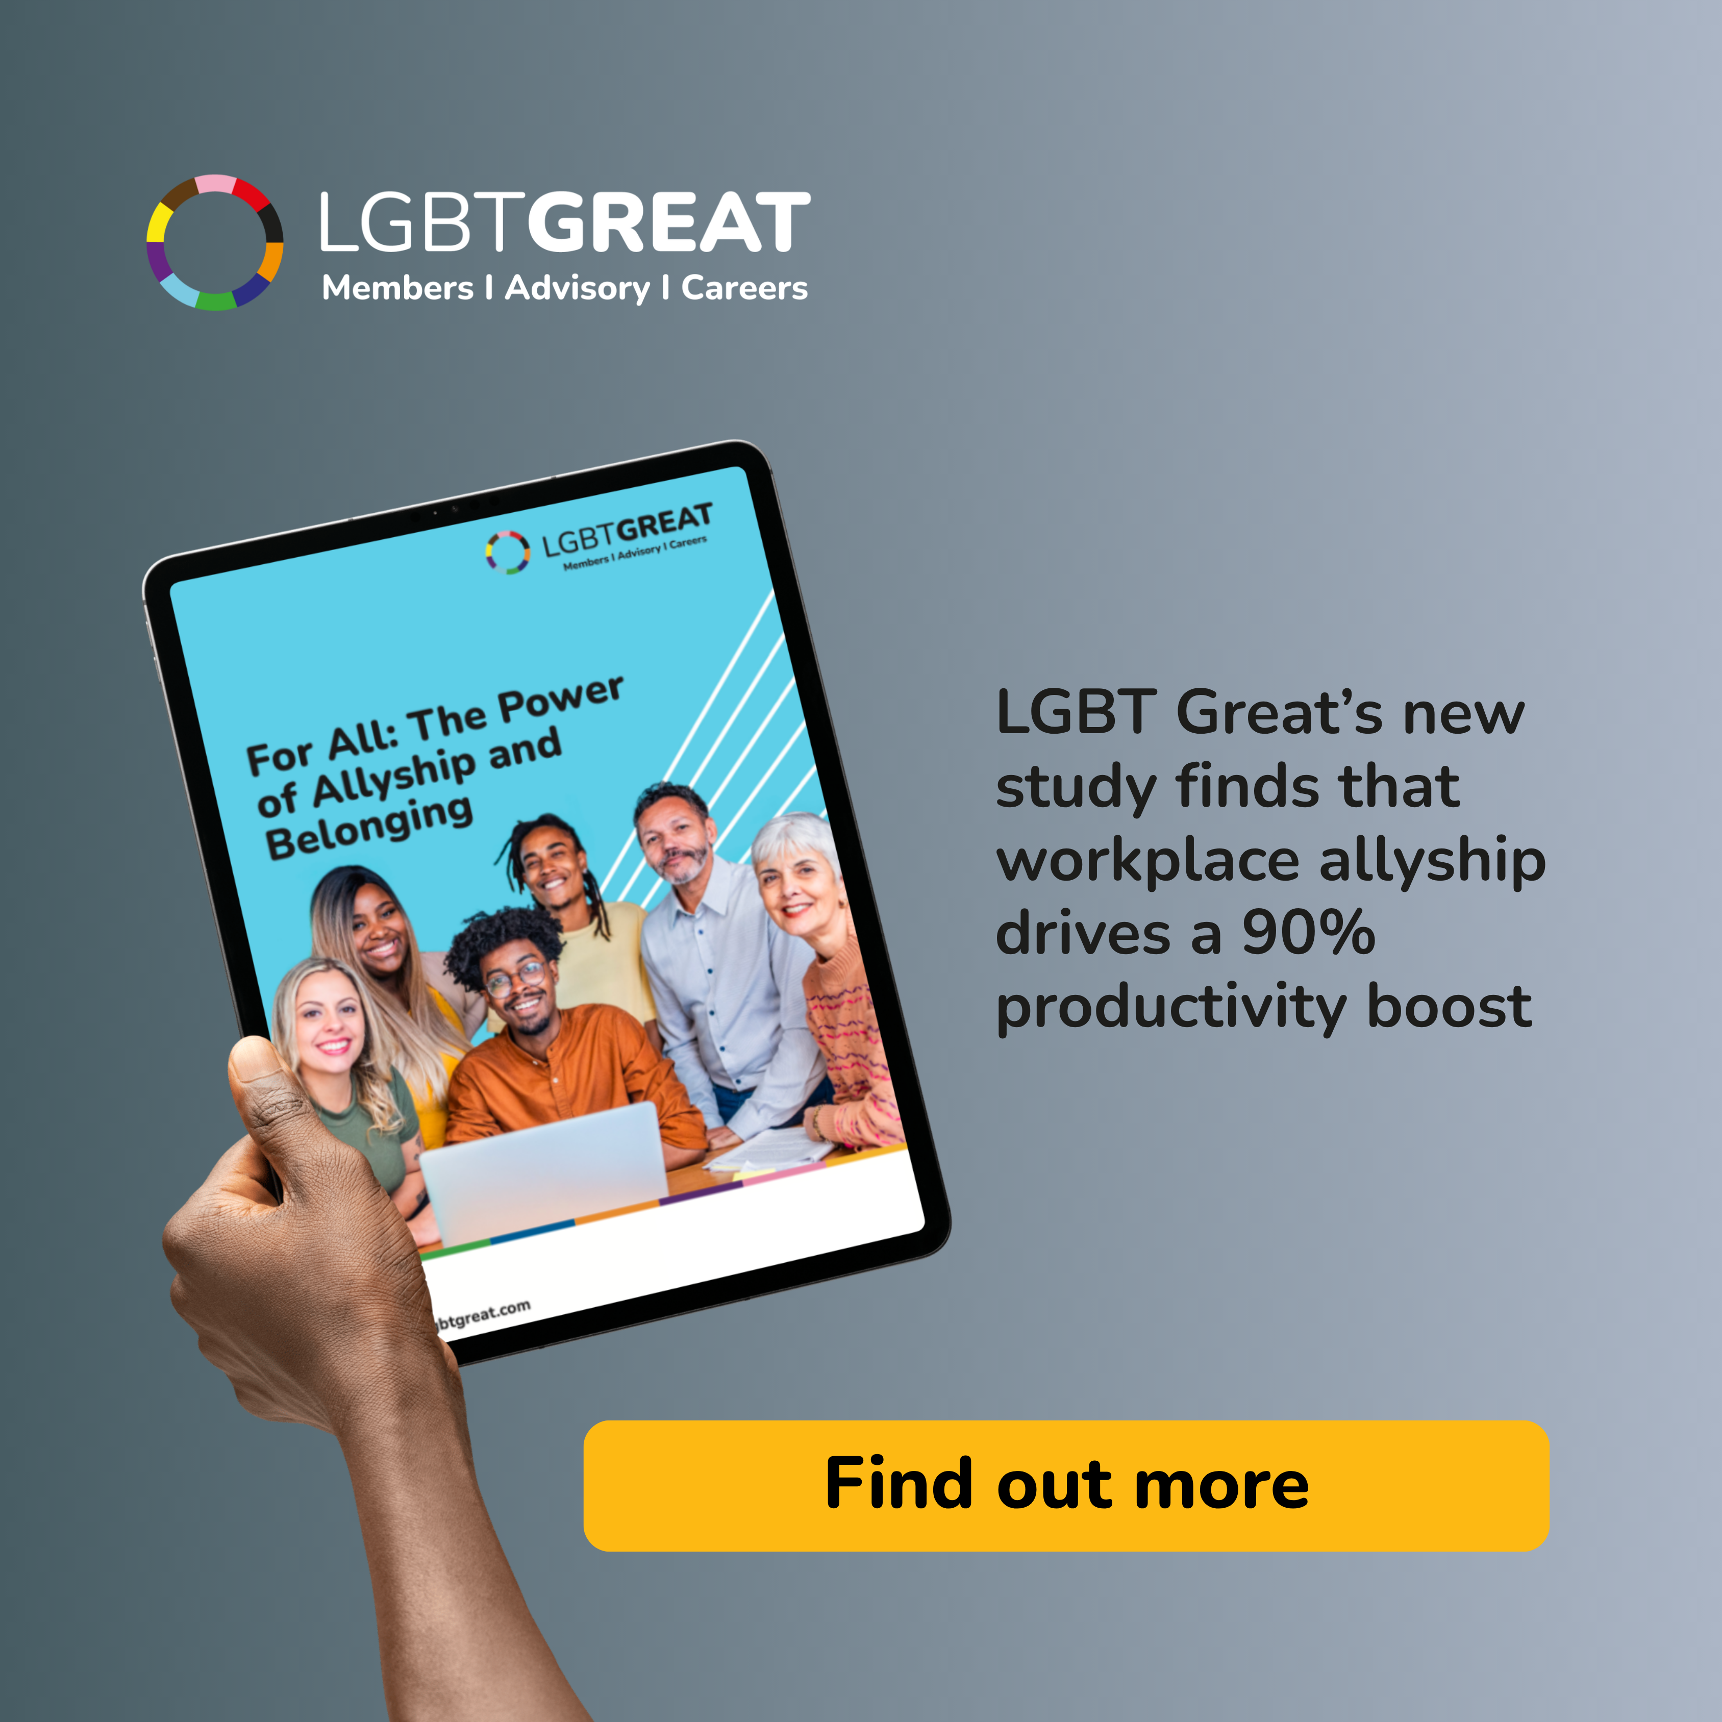 | True belonging in the workplace happens when allyship is experienced every day.  I'm excited to share LGBT Great’s latest research, For All: The Power of Allyship and Belonging, which found that 81% of respondents agree that allyship contributes to a stronger sense of belonging.  Download the Executive Summary here: https://www.lgbtgreat.com/For-All-Exec-Summary  Find out more here: www.lgbtgreat.com/For-All  #TheBelongingAdvantage #LGBTGreat #ForAll #Allyship #SeeingIsBelieving

Tags: @LGBT Great

