Dear all,

As you know, January is National Mentoring Month, to recognise the importance of mentoring and the positive impact it has on people’s lives.
Help to show the pivotal role of mentoring in fostering personal growth, professional development, and a fostering a sense of belonging for LGBTQ+ talent in [firm name].

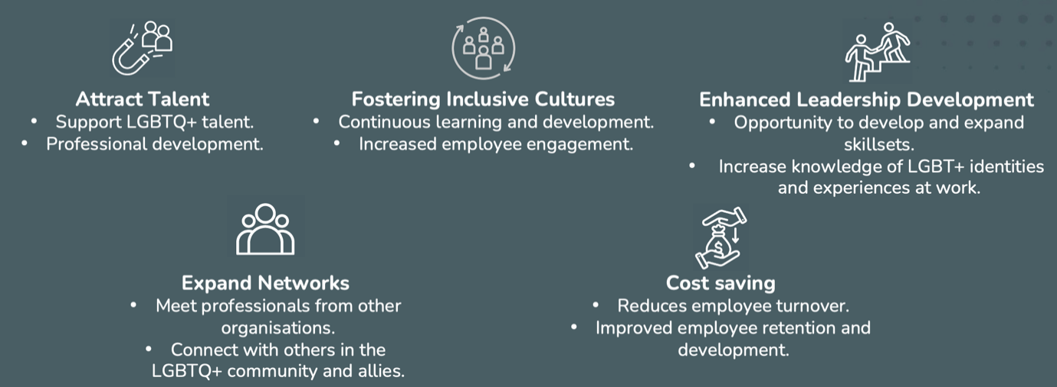

Please find below the following useful resources from LGBT Great for you:
- Mentees: What’s in it for you toolkit
- Mentors: What’s in it for you toolkit
- Sign up to the LGBT Great Going For Great Mentoring Symposium here in partnership with Nomura. Face to face event on the 27th of March from 4pm to 7.30pm at their offices in London. Click here for the full agenda.
- Become a LGBT Great mentee here/ Become a LGBT Great mentor here.
As we continue to build a thriving and sustainable business, I encourage everyone to think about how they can contribute to mentoring efforts. Whether you’re a seasoned professional with valuable experience to share or a new employee seeking guidance, mentoring is a mutual relationship that benefits both parties.
Let’s continue to support each other’s growth and development—together, we can build a stronger, more resilient organisation. Creating authentically inclusive workplaces. Because when your people prosper, everyone thrives.

Kind regards,
[Your Name]

