2024 Pride | LGBT Great Member Social Media Toolkit
Created by LGBT Great
Instructions: Curated social media copy has been created exclusively for LGBT Great’s members to use on their social media platforms. You are able to simply copy and paste the designated text into the corresponding graphic asset, as shown in the table below. These descriptions can be modified to your liking, as they are to help you with your marketing efforts for this high-impact campaign.
Hashtags: The suggested hashtags are located at the bottom of the page. Please include these hashtags in every post if you can. The suggested tags are shown at the end of the social media copy.
Tags: LGBT Great and the other members will help increase your visibility and exposure, and that of the event. Our tags are shown at the end of this document.
Queries: If you have any questions or would like to make any adjustments to the graphics or copy, please contact our Marketing & Events Manager: Callum Read (he/him) on Callum@LGBTGreat.com
# | Graphic | Name | Copy [Copy/Paste ]
Saturday 1st June | 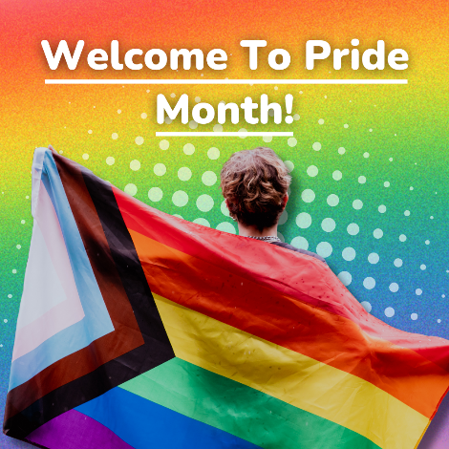 | Welcome To Pride | ‍Welcome to Pride Month!‍  We are proud to come #TogetherWithPride alongside the entire LGBTQ+ community and LGBT Great as we build a prouder world of work in Financial Services globally!  Pride is a time to remember the accomplishments of the LGBTQ+ community throughout history. It is also a joyous celebration of love, identity, acceptance, and self-expression.  Whilst much progress has been made, there is still lots to do  Commit to LGBTQ+ inclusion, build allyship, community and knowledge within your organisation to positively impact your workplace culture and behaviour. Get involved in #TogetherWithPride here: https://www.lgbtgreat.com/Contact
Monday 3rd June | 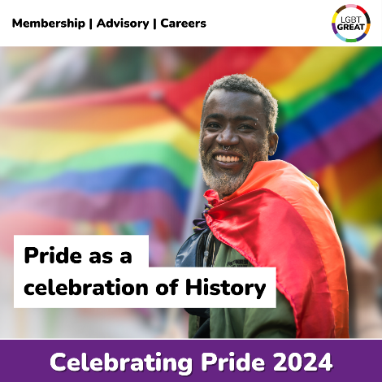 | History | Pride Month is a time to reflect on the history of LGBTQ+ people in and out of the workplace, a history of joy as well as fighting for equality.  Reflecting on our shared history can help us to acknowledge the progress made so far and recognise the challenges still ahead, together we can continue to build a prouder world of work.  You can learn more about what LGBTQ+ history means in the modern day by reading LGBT Great’s History Month Blog:  https://www.lgbtgreat.com/blog/reflections-lgbtq-history-month
Monday 10th June | 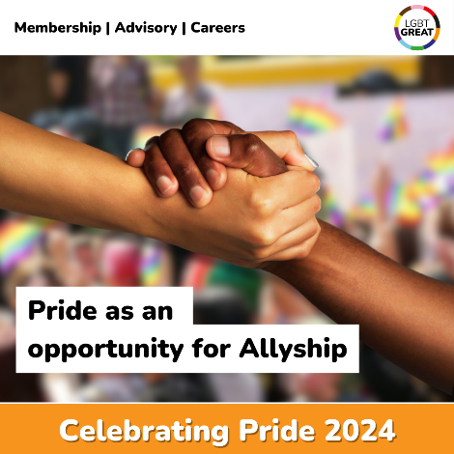 |  | Pride has always gone hand in hand with Allyship.  Allyship can take many forms, and effective allyship can help us all to foster a safe and inclusive environment where everyone can reach their full potential. This Pride, lets come together to celebrate effective allyship in all of its forms.  Remember Allyship is a verb! You can find out more about how to be an effective ally. Read the LGBT Great’s Allyship Guide here:  https://www.lgbtgreat.com/sites/default/files/2024-05/Striving%20For%20More%20Authentic%20Allyship%20Guide%20%20-%20June%202024_1.pdf
Monday 17th June | 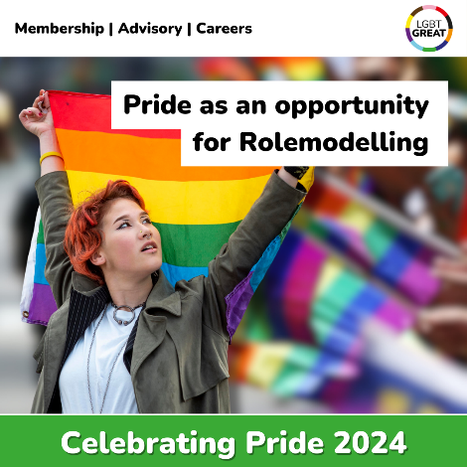 |  | Today we are recognising the impact of Role Models in Pride.  Role Models are a powerful and, at times, overlooked part of the working world. Having someone in the workplace acting as a visible ally or role model can help LGBTQ+ people feel more comfortable in the workplace.  To Find out more about Role modelling, click here to read the LGBT Great’s Seeing Is Believing Report:  https://www.lgbtgreat.com/research/seeingisbelieving
Monday 24th June | 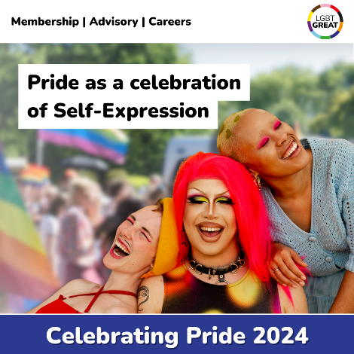 | Self-Expression | Pride has always been about self-expression, a time when everyone can be free to express their genuine self, no matter their sexual orientation or gender identity.  Come #TogetherWithPride this month to celebrate our differences, shine bright, and empower others to be their authentic selves, fostering acceptance and inclusivity.  Together we can build a prouder world of work where everyone can embrace their uniqueness.
Suggested Hashtags:

#TogetherWithPride #Pride #LoveIsLove #LGBTQ #PrideCommunity #PrideMonth #EqualityMatters #PrideCelebration #ProudToBeMe

Please Tag LGBT Great’s Social Media Channels:
- LinkedIn: https://www.linkedin.com/company/lgbtgreat/

- Instagram: https://www.instagram.com/lgbtgreat/

- Twitter: @LGBTGreat

- Facebook: https://www.facebook.com/LGBTGreat

