2024 Pride | LGBT Great Member Social Media Toolkit – Sister Act Charity Gala
Created by LGBT Great
Instructions: Curated social media copy has been created exclusively for LGBT Great’s members to use on their social media platforms. You are able to simply copy and paste the designated text into the corresponding graphic asset, as shown in the table below. These descriptions can be modified to your liking, as they are to help you with your marketing efforts for this high-impact campaign.
Hashtags: The suggested hashtags are located at the bottom of the page. Please include these hashtags in every post if you can. The suggested tags are shown at the end of the social media copy.
Tags: LGBT Great and the other members will help increase your visibility and exposure, and that of the event. Our tags are shown at the end of this document.
Queries: If you have any questions or would like to make any adjustments to the graphics or copy, please contact our Marketing & Events Manager: Callum Read (he/him) on Callum@LGBTGreat.com

# | Graphic | Name | Copy [Copy/Paste ]
Pre-Event |  |  | I’m excited tonight to be attending the Sister Act Charity Gala with @LGBT Great and @OKRE.  I’m proud to be supporting the #KindQueerHeart initiative to empower new LGBTQ+ talents in TV, film, and games. Together, we aim to broaden representation and accelerate acceptance through compelling story telling and narratives.  #KindQueerHeart #SisterAct #IDAHOBIT #OKRE #TogetherWithPride #LGBTQ #LGBTGreat
Post- Event | 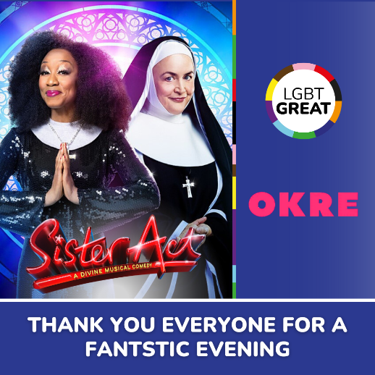 |  | What a great night! I really enjoyed the Sister Act Charity Gala with @LGBT Great and @OKRE. A huge thank you to the cast and crew, and everyone else who made the night so special.  The gala raised funds for the OKRE #KindQueerHear initiative which seeks to increase LGBTQ+ representation in TV, film, and games. You can donate to the fund here:  https://wonderful.org/fundraisers/NJZqN  #KindQueerHeart #SisterAct #IDAHOBIT #OKRE #TogetherWithPride #LGBTQ #LGBTGreat | History | Pride Month is a time to reflect on the history of LGBTQ+ people in and out of the workplace, a history of joy as well as fighting for equality.  You can learn more about what LGBTQ+ history means in the modern day by revisiting LGBT Great’s LGBT History Month Blog:  [Link]
Suggested Hashtags:

#KindQueerHeart #SisterAct #IDAHOBIT #OKRE #TogetherWithPride #LGBTQ #LGBTGreat

Please Tag LGBT Great’s Social Media Channels:

- LinkedIn: https://www.linkedin.com/company/lgbtgreat/
- Instagram: https://www.instagram.com/lgbtgreat/
- Facebook: https://www.facebook.com/LGBTGreat/
- Twitter: @LGBTGreat

